



**SM6P07NI Digital Media Project**

**20% Research and Proposal**

**2021-22 Autumn**

**Student Name: Arbindra Adhikari**

**London Met ID:**

**College ID: NP01MM4S190024**

**External Supervisor: Sandip Lamicchane**

**Internal Supervisor:**

**Assignment Due Date: 28th Dec 2022**

**Assignment Submission Date: 28th Dec 2022**

**Word Count: 1360**

*I confirm that I understand my coursework needs to be submitted online via Google Classroom under the relevant module page before the deadline in order for my assignment to be accepted and marked. I am fully aware that late submissions will be treated as non-submission and a marks of zero will be awarded.*

**Abstract**

This project is mainly about creating a proper documentation where it complies all the necessary elements which are related to TVC Advertisement making and all the necessary aspect by which a successful Musical TVC can be made. This documentation includes all the necessary research done in the field of this project and proposal of the project. This particular documentation can be divided into two parts. talking about the first part of the project it includes all the aspects related to the Client research. It includes the topics like literature review, product review, Client research and many more. This particular section also includes all the elements which are necessary for the proper branding propose. Talking about the second part of this project documentation it talks about the titles like the topic or the title of the project, treatment and also contribution of others. This part also talks about the testing process in which the proper knowledge about this project has been made and initial survey till gives the room for improvement.

Contents

# Section A: Research

# 1) Introduction:

🡪 Video production is the process of making video content for videos. It's the same as making a movie, but instead of utilizing film material, video is captured as digital signals on analog tapes or as computer data on optical discs, hard drives, SSDs, magnetic tape, or memory cards.

A proper plan is required for the project to be successful. Without a strategy, the video may not be successful. Without a proper script, shot planning, and a storyboard, one cannot imagine generating a wonderful video. which stands out to the mass, therefore for the project's success, the works are required to be split into three phases, which are as follows -:

Three stages of video production are pre-production, production (sometimes known as principal photography), and post-production.

**🡪 Pre-Production phase**

Before filming begins, all of the planning aspects of the video production process are included in pre-production. This includes tasks related to scheduling, logistics, scriptwriting, and administration.

* **Production phase**

Production is the phase that comes before and after post-production. It is where raw elements are recorded and footage is taken for the video. It includes all of the work such as shooting, working with the director, camera crew, and other crew members to block out actor movements and lighting set ups for a scene.

* **Post-Production phase**

It is the stage after production, which encompasses all stages of production that occur after shooting or recording individual show segments. When the raw footage is collected and processed, the editing of the visual and audio materials begins, the phase generally involves of content editing, sound editing and music addition, visual effects addition, color correction etc.

The first ever TVs

At the height of the second world war, the initial television advertisement debuted. A portion of these promotions were entertaining, others were inspiring, and a couple were down changing oner the long run. They became a phenomenon in popular culture over time.

The world’s first television commercial aired for the Bulova Watch Company. The ad was only 10 seconds long, cost between $4 and $9 to create ans was seen by 4,000 people in New York.

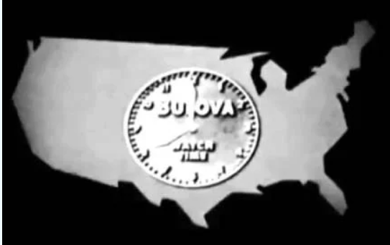

**History of commercial**

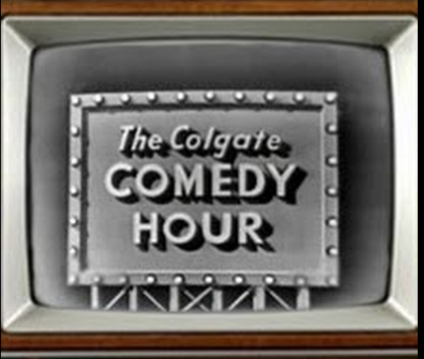

Sponsored programs were popular with big companies like Coca-Cola, Mattel, and Colgate. During the shows, these brands were talked about, and sometimes they were even incorporated into the show's name, like The Colgate Comedy Hour.

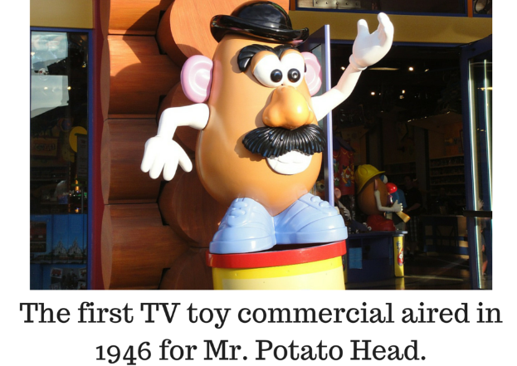

Source <https://twitter.com/stuffineverknew/status/723547750948823040>

The first toy to be featured in a TV commercial was Mr. Potato Head. This vintage Tv commercial for Mr. Potato Head is the first toy advertisement aimed at kids, and is just as creepy and weird as you’d imagine. In the first year alone, nearly 2 million Mr. Potato Heads were sold.



China’s first tv commercial appeared on January 28,1979. This first commercial was broadcast on shanghai Television and ran for 90 seconds. The advertisement was for a product called ginseng tonic wine. The commercial tells the story of a girl who goes to the store with her parents to buy a bottle of tonic as a gift for her grandfather. Despite it’s simple content, the ad had a big impact. Suddenly, everyone wanted to buy Shen Gui Tonic Wine.

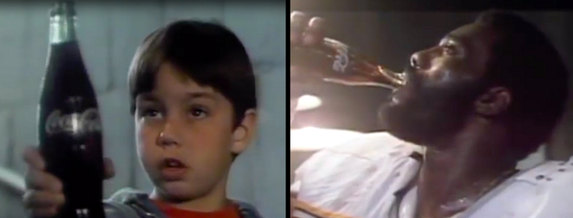

"Hello, kid, catch!" is a Coca-Cola commercial starring "Mean" Joe Greene, a defensive tackle for the Pittsburgh Steelers. The advertisement first aired on October 1, 1979, and it was rebroadcast several times, most recently during Super Bowl XIV in 1980. One of the best television commercials of 1979, the 60-second spot won a Clio Award.

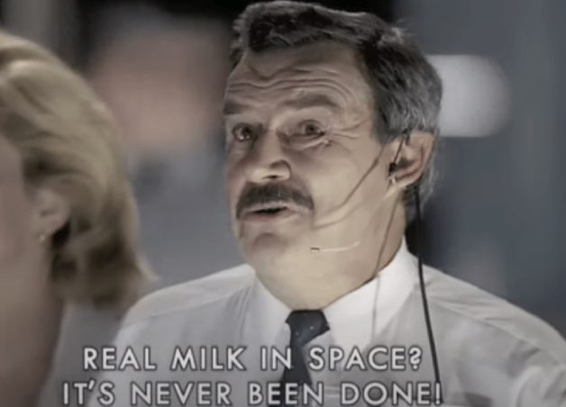

On August 22, 1997, a commercial for Tnuva Milk featured cosmonaut Vasily Tsibliyev sipping milk aboard the Russian Mir space station. Alexander Lazutkin, a former flight engineer, used a camcorder to record crew commander Tsibliyev while being instructed by the commercial's director, who was watching from the Control Station. This was the first-time milk in liquid form had been sent into space. The ad made it into the Guinness Book of World Records.

The Apple Macintosh personal computer was introduced in the American television commercial "1984" It was brought about by Steve Hayden, Brent Thomas and Lee Clow at Chiat/Day, created by New York creation organization Fairbanks Movies, and coordinated by Ridley Scott. Three months after the advertisement aired, the company sold $155 million worth of Macintosh computers.

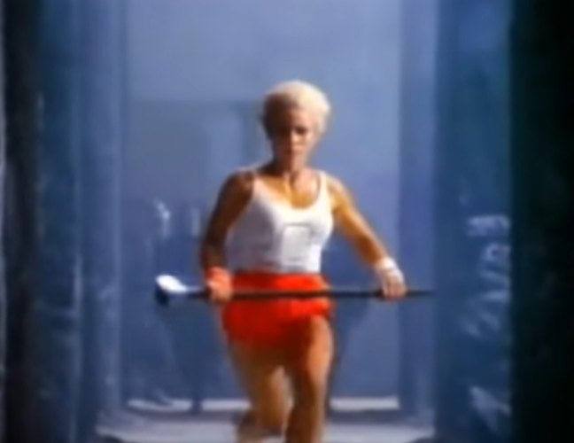

Unilever launched the Evolution advertising campaign, also known as The Evolution of Beauty, in 2006 as part of its Dove Campaign for Real Beauty to promote the newly established Dove Self-Esteem Fund. To become a model for the advertisement, a woman underwent a lengthy process of hair, makeup, and Photoshop.



On May 5, 2003, LinkedIn made its debut. With its mission to "create economic opportunity for every member of the global workforce," the platform for professional networking LinkedIn brought some of their most memorable businesses. The idea for the advertisement, which ran during the 88th Academy Awards, was NASA's decision to use the networking platform to find new astronauts.

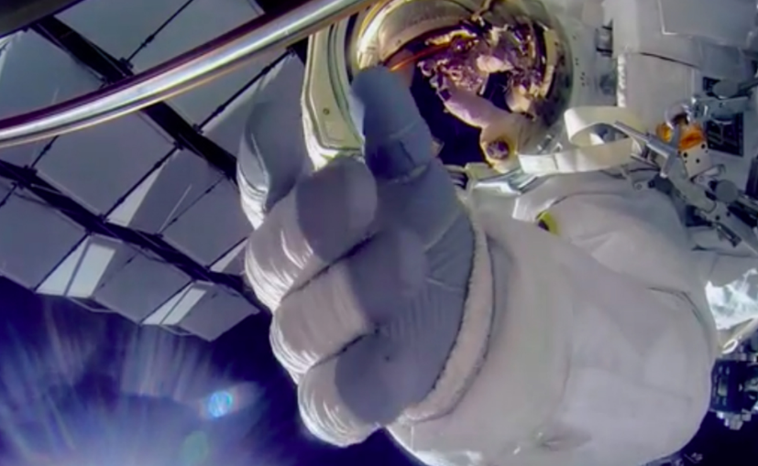



The way we watch advertising has changed thanks to Hulu. Depending on how many ads they want to see, viewers can select a package deal, some of which are even exclusive to the streaming service.

44% of responders said that streaming services like Netflix and Hulu have reduced their use of live TV. People don’t want to be disturbed by commercials leading to a decline in commercial ads.

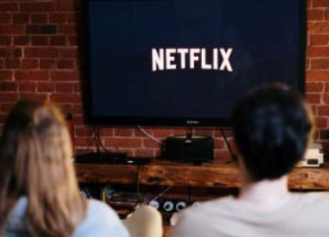

**2) Client research**

The clients are the folks from the silauto cottage located in annamnagar kathmandu, they have been running the cottage for more than 3-4 years and are kind and really helpful. They work really hard to ensure that the cottage deliveres their best so as to make the customer feel like a home they have various nepali cuisine as well as delicious fast food items not only that but many tradition nepali items like sillauto,theki,laltin nanglo as well. The environment inside the cottage is really great filled with nature and fresh set of air.

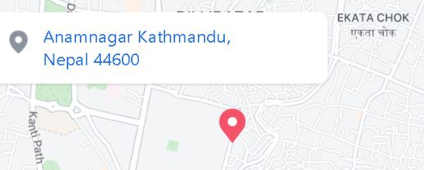

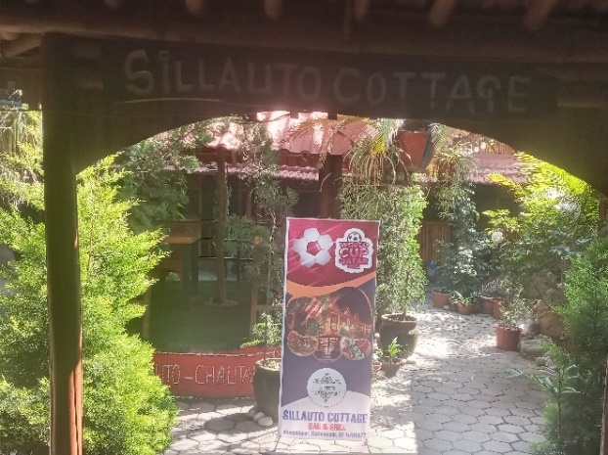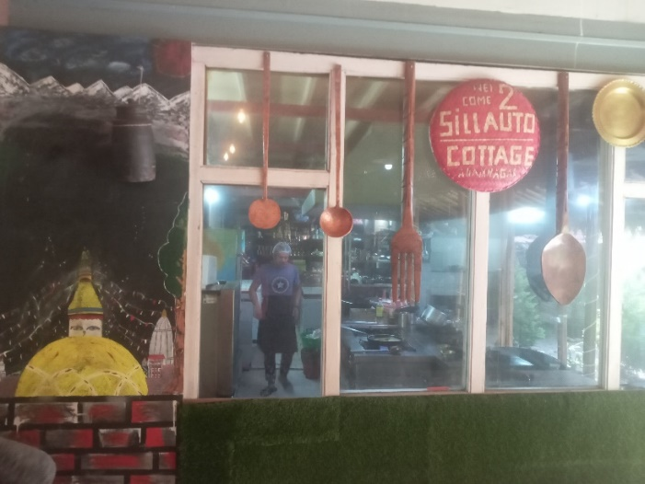

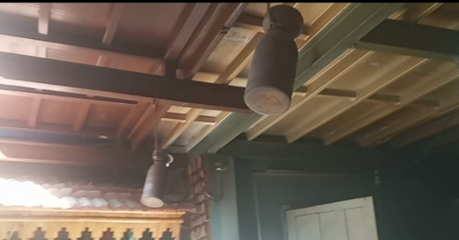

There is a big sillauto inside where they grind the spices and many more traditional Nepali items . The cottage is having a very good environment and great ambiance as well as great customer services for the audience, not only you can enjoy peaceful sound of the waterfall you can enjoy your delicious foods items with family and friends.

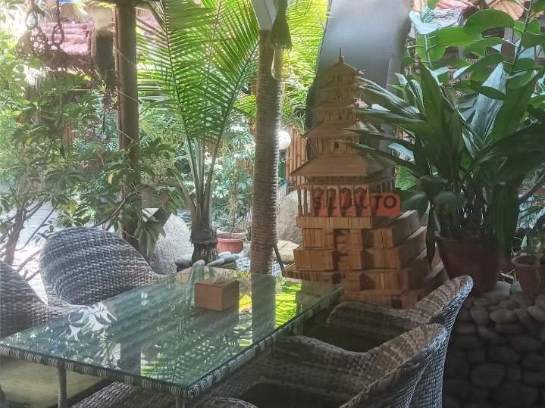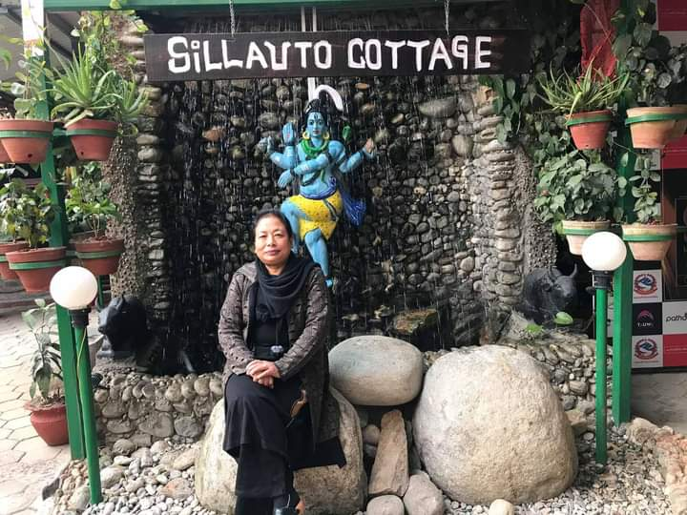

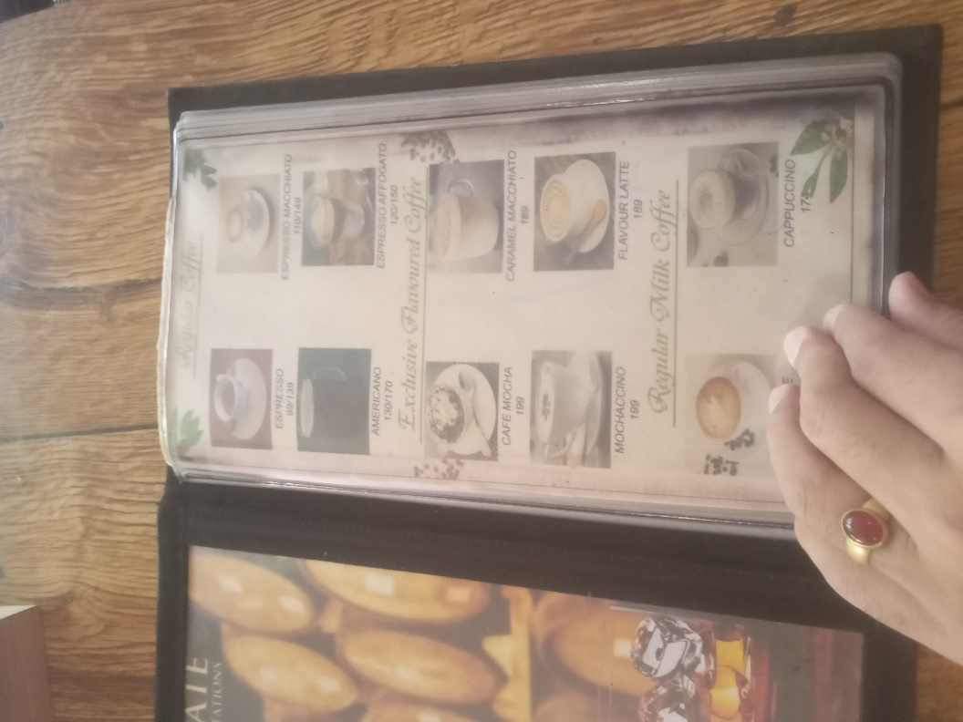



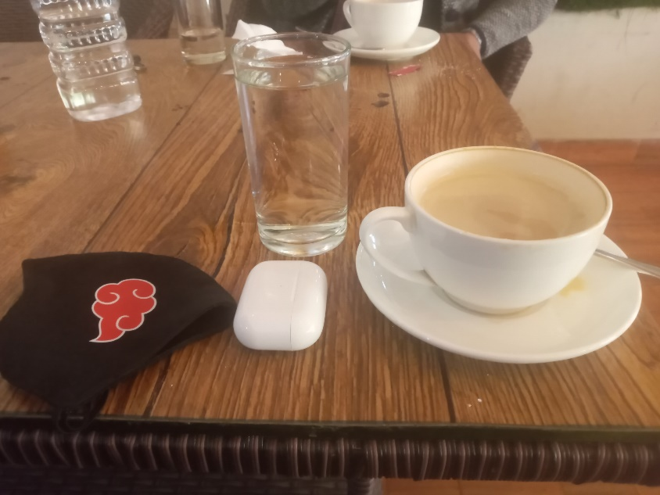

The menu for the cottage bar and grill, you can enjoy all your Nepalis cuisine, morning to dinner worth of foods with the facility of home delivery at any time.



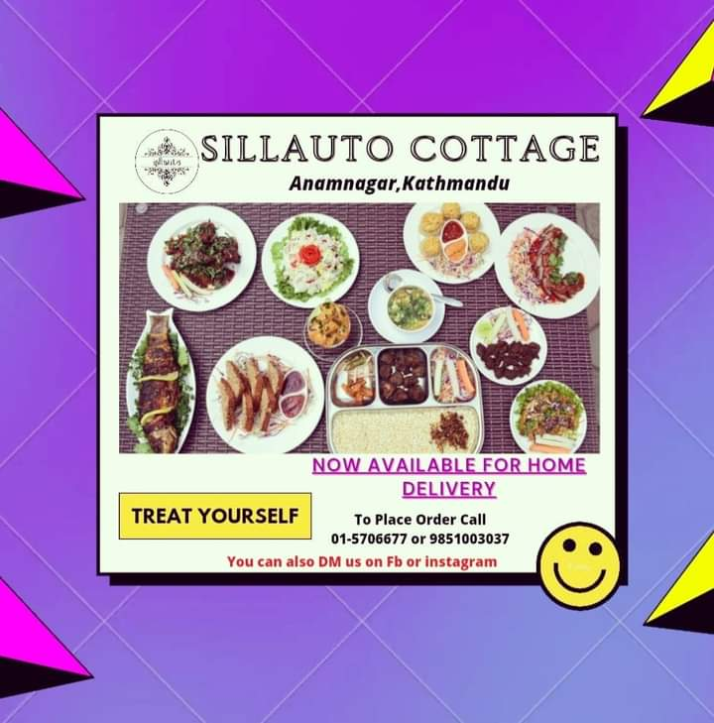

There are many varieties of foods items at the cottage like more of your traditional Nepali food items and typical Nepali cuisine on the board.



**Literature Review**

For my project I am planning on doing a video production i.e., shooting a TVC commercial which will be a real client-based project, I will be combining all my knowledge on music and video shooting with some 2d if possible, while shooting for the video definitely there will be lots of issues to digest like less people to shoot, actor and drone shot, to solve and overcome them I have asked some help from staffs and some friends for the drones and the customers for some acting if possible.



**What were TV Commercial like in the 1960’s?**

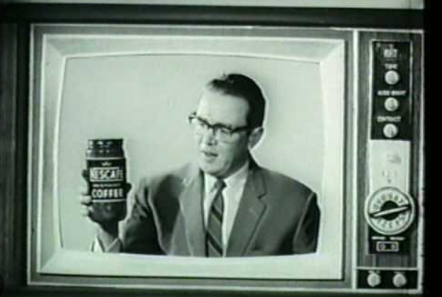

More than one commercial could air on a single show by the 1960s. As a result, more businesses were able to benefit from this marketing strategy. Additionally, since television was now available in color, the possibilities were endless.

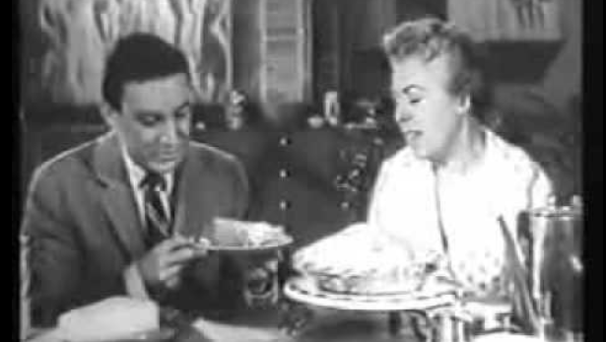

You have to look at sponsored programs in the past to see how revolutionary commercials were in the 1960s. The advertiser had complete control. They had complete creative control over the content because they were paying for the advertisements that ran during the shows.

**What makes a great television advertisement**

**🡪** The process of making and airing commercials for a product or service on television is known as television advertising. Most commercials are between 15 to 60 seconds, Each day, the average person watches about four hours of television. This gives advertisers a lot of chances to get their message in front of people who might buy from them. The impact on popular culture is what makes television advertising truly valuable. The most memorable TV commercials present a story, appeal to our emotions, or include a catchy tune or humorous event. It really is the advertiser's responsibility to make sure that kind of commercial is being produced.

Some examples of tv advertisement can be

**Future of tv commercial**

**Types of commercial videos**

**3) Product Review**

I’m trying to promote the hotel experience encouraging people through the advertisement and convey a message to the public in a fun way through the means of motion graphics and music.

The project has some inspiration from some emotional food advertisement as well as many hotel/ foods houses advertisement. Some of the video I watched and took some ideas.

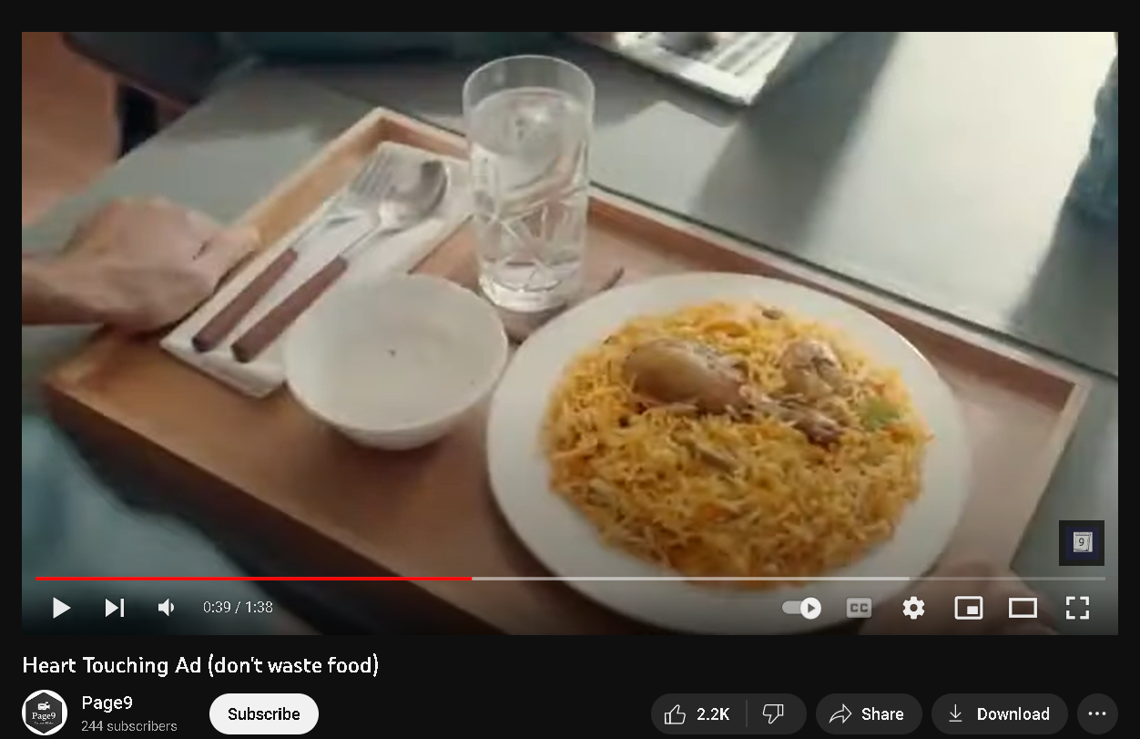

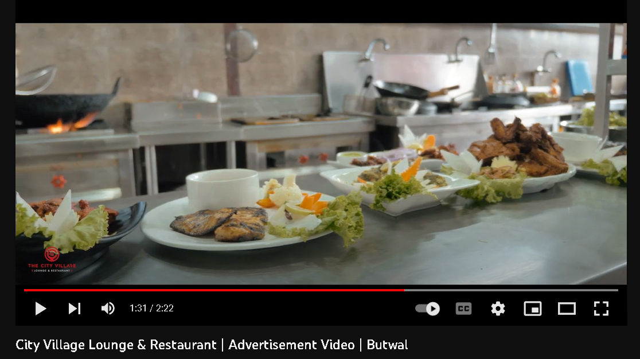

I really loved the way the video started and how it ends. It captures the inside very well and gives some inspiration.

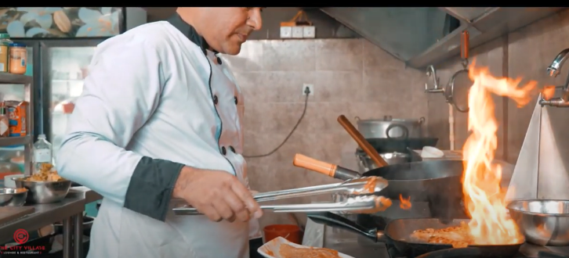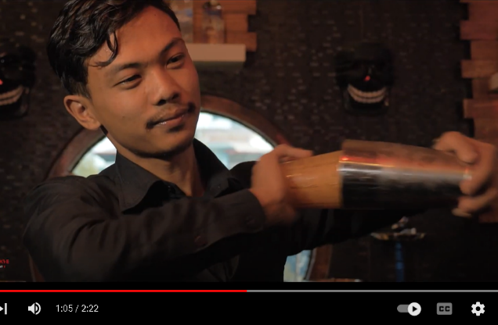

Similarly like in the videos above I will be having some emotional moments related to food also as in the 2nd video I will be showing various food items inside the food cottage, the cinematics environment inside the place and the staff working in the kitchen the ambience and customer service will also be shown through the video. I will be creating some great beats and music for the video there will be slight music on the background later in the video, the music will change be according to the feeling of the character in the video.

The music will change according to the feel of the character, so that the viewer watching the video can also relate and feel the same.

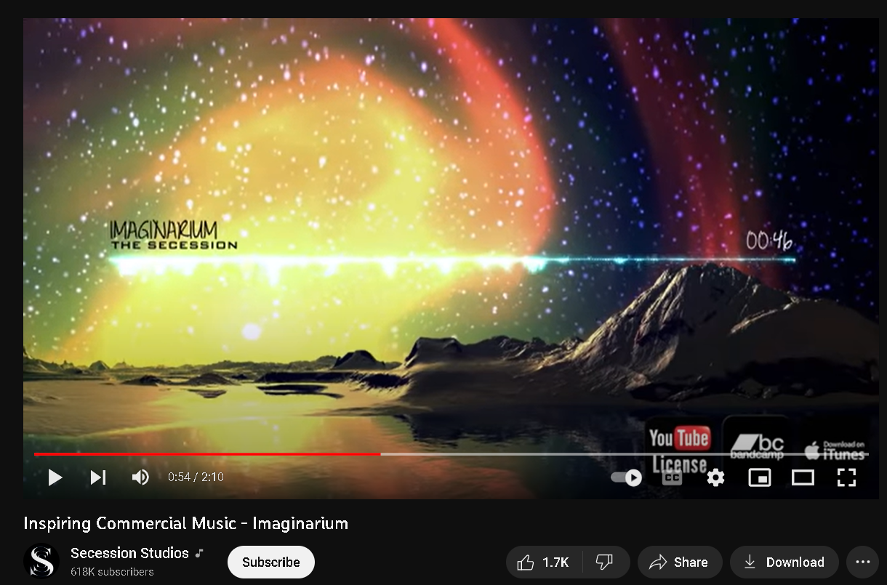

I looked up various commercial music’s in YouTube, and I came across the above music’s which were really my inspiring.

**4) Summary and Conclusions**

This coursework has enlightened me about client-based work film making and camera angle for shooting, which was very helpful and, it has taught me the importance of planning and management of crew, budget, cinematics and, more about, the history of tvc Thank you, sir/Madame,’ for your support and guidance.

Overall, the video should show a proper promotional TVs advertisement which can give a proper message as well as satisfy the viewer and hence attract the people to actually go to the place.

Section B: Project Proposal

**1) Project Title**

A Sillauto cottage experience

In the video I will show a guy really starving and ready to pass out I want to capture the feeling of hunger.

Objectives

🡪 To promote the place for the people watching.

🡪To connect with the viewer

**2) Research Question**

* How is the video going to help promote the cottage in anamnagar?
* Can the video capture be unique and catch the heart and many audients?

**3) Treatment**

🡪 Talking about the perspective of the audience after watching this short commercial it is going to be very emotional and very loveable. This television commercial will give the viewer an experience of a food hut, Audience will connect to this TVC as there will be a emotional message at the end showing love for foods and your country, this advertisement will also show variety of traditional Nepal food to promote our culture. The audience can feel the patriotism and love for one’s country they will also get the idea as the story line is hitting the mind of the audience. The message which the story from the TVs is trying to give is that restaurants experiences can be more fun than they imagined they are not expensive and waste of there money, The commercial will always be remembered in the mind of the audience as there is emotional connection of the country and its food.

**4) Resources**

**Software**

Adobe software’s will be used to create motion graphics and editing the footage

Da Vinci/premier pro for color grading

FL studio/reason will be used to create sounds and beats according to the mood of the scenes in the video

**Equipment’s**

* The following are the resources required to shoot and complete the project.

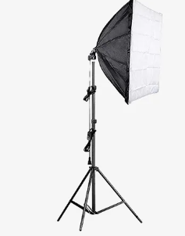

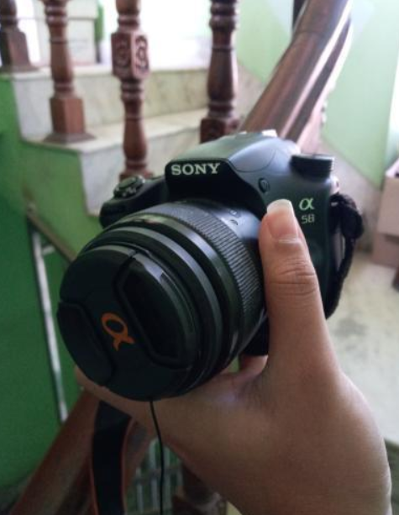

**Lighting 🡪 Rent**

**Cameras 🡪**

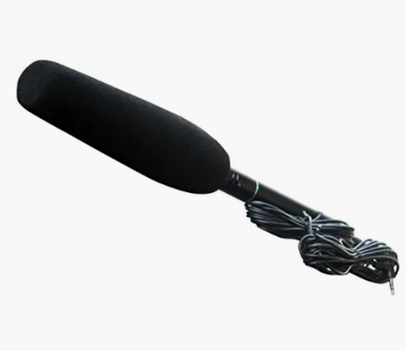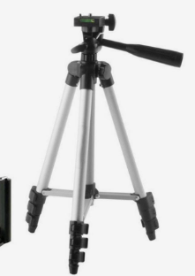

Microphone

**Tripod 🡪**

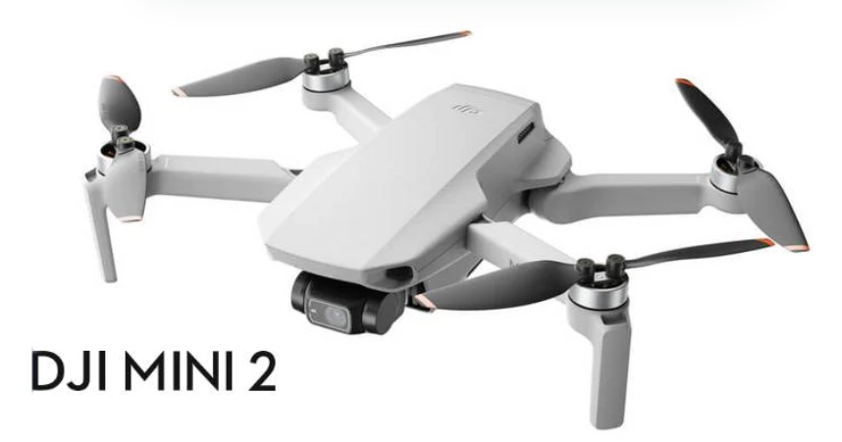

**Hardware**

Processor 🡪 Intel(R) Core (TM) i7-1065G7

Installed RAM 🡪 8.00 GB

System-type 🡪 64-bit operating system, x64-based processor

**5) Contribution of Others**



The project was only possible because of the people who had given me permission to shoot, the humbleness, their kindness and helping nature was also great contribution.



🡪 The staff were very supportive and respectful, they are going to be a huge help for serving the food item and helping in the video.

The Staffs

The Staffs

Mom

* She introduced the place and I was really satisfied, she has a big contribution for helping, Fist time going I thought it will be small place but turned was it wasn’t what it seems, it was great inside and after seeing the traditional food items, the environment inside and staffs I was ready to see how I can make a great TVC video out of it.

Friends

* I have asked friends to borrow drones and have seek some ideas on the camera angles and some help for the shoot, like managing lighting and discussion on how to make it better with them.

**6) Evaluation & Testing**

Evaluation is a very importance process as evaluation paves the way to project improvements.

By displaying it to my coworkers and friends, I will assess my progress. Additionally, I will evaluate my project based on my weekly progress. Since this is a project that will last a year, I want to get as much advice and feedback as I can from everyone I know, including my supervisors and colleagues.

After completing my project, I will be first testing the game myself and pass it on to my supervisors, friends and family to get feedback.



7) References and Bibliography

<https://www.wikipedia.org/>

<https://www.qualitylogoproducts.com/promo-university/history-of-tv-ads.htm>

video ideas

<https://www.youtube.com/watch?v=qOQtQFh6WFs>

<https://www.youtube.com/watch?v=pDr3WepjFTU>

<https://www.youtube.com/watch?v=rg6_e9eMp-s&list=PLNpruo3rG6fm_3C3RqEwr5hH7jogoZ7yb&index=3>

Theory ideas

<https://www.lemonlight.com/blog/6-categories-of-commercials-for-your-business-videos/>

<https://stadamedia.co.uk/blog/how-to-make-a-tv-commercial-the-whole-process/>

<https://www.feedough.com/television-advertising-definition-types-examples/>

9) Appendix

**Legal and Ethical Considerations**

Before beginning the project, legal and ethical considerations must be made. I was aware of such terms; for copyright difficulties, I would ensure that I have a valid letter before obtaining approvals and authorization. I will only shoot after obtaining permission from the owner to utilize various elements in the video.

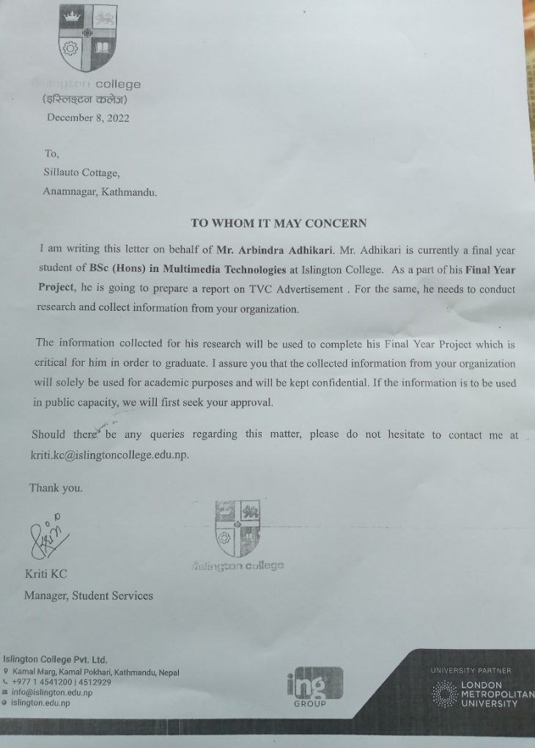

**Gantt chart**

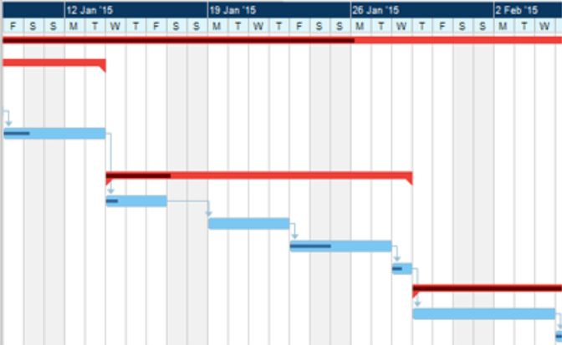A Gantt chart, which is widely used in project management, is one of the most popular and useful methods of displaying activities (tasks or events) against time. Each activity is represented by a bar, The position and length of the bar reflects the start, duration. and end dates of the activity.

Example of Gantt chart

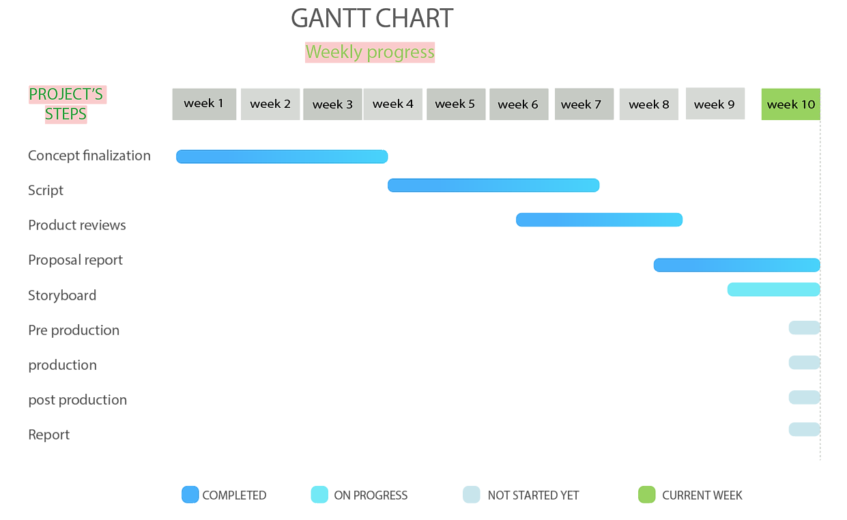

**My project Gantt chart**

**SCRIPT**

**LOGO AND INTRO**

Starts with showing bunch of hotels and a narration.

(Music piano)

Narration starts

[where ever you go there is nothing closer than your home

But what if your home was ......]

<Video transitions >

{FADE IN}

A person who is really depressed tired from journey and starving while walking in the road is shown in the video

with the (Display of sad vibe/music)

He is in state of exhaustion and about to pass out just then he crashes to the nearby shop and feels the energy and excitement coming inside the vast cottage like it’s calling out to him. (Effect)

(Dramatic silence)

He smells variety of foods and is simply mesmerized by the kindness of the people in the cottage serving him fresh drinks.

(Transition of music to exciting pattern beats)

He sees a small bakery shop but as it turns out its not what the eye meet

(Some great music beats)

He is amazed by the food items and its amazing variety, all the nepali foods and tradition displayed in the small yet amazing cottage gave him chills... (Inspiring beats

The great environment inside the cottage made him feel like his own home

{At last, his mood changes drastically and regained his strength like never before}

END

**Methodology**:

A methodology for project management is a set of principles and practices that help you organize your projects to get the most out of them.

Wrote script and shared with supervisor

Finishes my proposal and was clearer on my work.

Looked for inspiration on websites YouTube



Finalized my concept and ideas

Discussions with both supervisors

Found more videos on YouTube/website for even more idea.

My Roadmap